HMS has Property Records they create in their NetSuite environment. They have a custom table created that is used to capture these Property Records.



The Property Record has a custom form that looks like this.

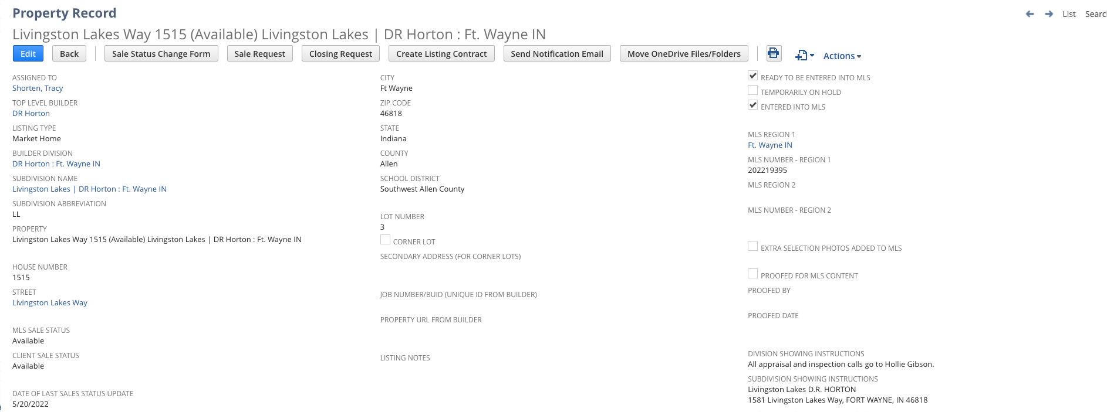

I believe the custom form used is this one

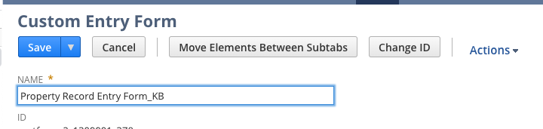

But in sandbox they do have this one marked as preferred on the custom record

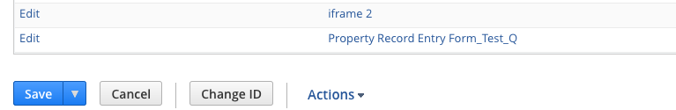

What they are looking for is to identify when certain fields are updated on this form and capture those in a custom table, much like we did for Delta Millworks for Customer Order Changes.

We need to create a custom table and similar scripting like we did for Delta Millworks to capture specific changes.

Custom Table: Please configure a custom record in NetSuite as follows

* Title Property Record Changes
* Fields
  + Property Name: This is titled as Property on the form, but is the ‘Name’ field as identified in the custom record. (free form text field) \*\*\* We do not want to include this field. It should be removed.



* Date Changed: This would be the date the field value was changed. (date type field)
* Field Changed: This would be the field name that was changed. (free form text field)
* Old Value: This would be the previous value that was in the field. (free form text field)
* New Value: This would be the new value that is in the field. (free form text field)
* Changed By: This would be the username of who made the change. (free form text field)

New fields to add to the custom table:

* MLS Region 1: This is on the property record

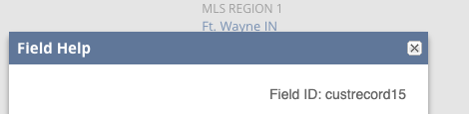

* MLS Region 2: This is on the property record

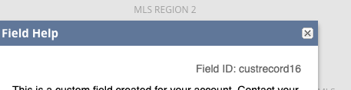

* Builder Division: This is on the property record

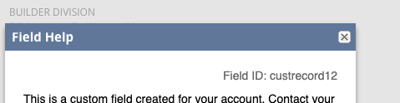

* MLS Sales Status: This is on the property record

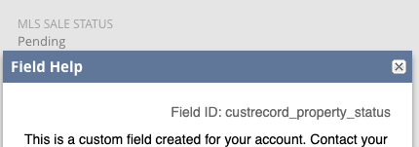

* Top Level Builder: This is on the property record

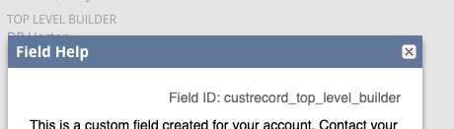

* Subdivision Name: This is a field on the property record, but is a custom record. The custom record is named Subdivision Record. On the Subdivision Record there is a custom field titled Subdivision Name. We want this value populated in the custom Property Changes record.

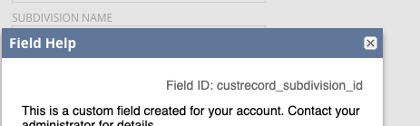

* Simple Name: This is a field on the property record located Custom sub-tab. We want to capture this field, but have the name of the field in the custom record be Address.

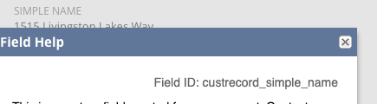

* Lot Number: This is a field on the property record. We want to capture this field, but have the field label in the custom table be Lot/Unit.

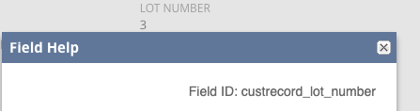

The key fields we need to trigger on are as follows:

* Client Sales Status (see screenshot below): If this status update equals Pending or Closed, then log the information into the custom table. This is located on the Main section of the form.

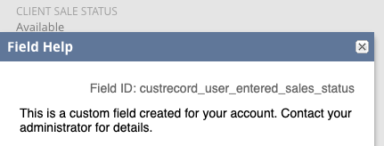

* Estimated Closing Date: If this field is updated at all, log a record in the custom table showing old value and new value. This is located under the Sales Details sub-tab of the Property form.

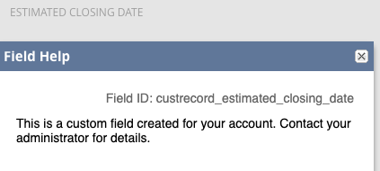

\*\*\* We want to put an update in the code that would ONLY capture a change to this field

IF the Client Sales Status value does NOT equal Closed. If Client Sales Status = Closed, then updates to the Estimated Closing Date should not be captured. Note: Client Sales Status is already a field change that we are capturing.

* When the Current Status of Construction field is updated, log a record in the custom table showing old value and new value. This field is located under the Listing Details sub-tab of the Property record.

\*\*\* We want to put an update in the code that would ONLY capture a change to this field for specific MLS record.

On the Property record there is a reference to MLS Region 1 and MLS Region 2.



These are setup using NetSuite’s standard Location record. Navigation is Setup > Company > MLS Regions/Areas

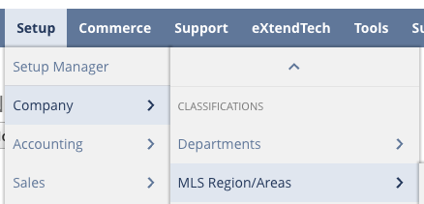

On these MLS records there are some custom fields. One of the custom fields is Construction Status Tracked. This is a checkbox field.

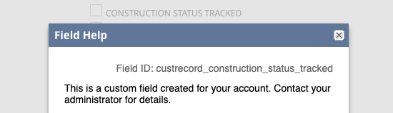

The update to the code is, only capture the change to Current Construction Status IF the MLS Region 1 has the Construction Status Tracked field set to TRUE.

NEW UPDATE

There is a field on the Property Record titled MLS Sales Status

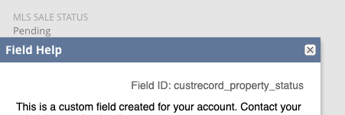

What we want to do is if this field is updated to a value of Closed, then check the custom Property Record Changes table to see if there are any records in there for that Property where the Inactive field is set to FALSE and set the Inactive field to TRUE.

This is ideally a ‘real time’ update, so client or user event, but if we can’t do that it can be scheduled.

The updates to these fields can be manually done via the forms or (most likely) imported via API’s.

Again, this is really the same development we did for Delta Millworks, except it is being done on a different record type.

You can use this property record for testing in sandbox.

<https://1309901-sb1.app.netsuite.com/app/common/custom/custrecordentry.nl?rectype=18&id=43058&whence=>

Mike